
Department of CSE

B.Tech. CSE Trimester -5

Roll Number : 2520030054
Name : Perugu Manisha

Cloud Infrastructure and Services
25CS2206E

SKILL RECORD
2026

Experiment -1

AIM:
1. Create an IAM user with programmatic access only, download the access key and secret key, and document the steps with screenshots.Then set up a billing alert for the account so that an email is received when the Free Tier limit is about to be crossed.

Description:
In this experiment, an IAM user was created in AWS with programmatic access only. The Access Key ID and Secret Access Key were generated and downloaded for secure authentication. The process was documented with screenshots.
A billing alert was configured in AWS Billing and Cost Management by creating a budget and adding an email recipient. This helps monitor AWS Free Tier usage and receive email notifications when usage approaches the configured budget threshold, helping to avoid unexpected charges.

Steps:
1. Open the AWS Management Console and navigate to IAM (Identity and Access Management).
2. Select Users, choose Create user, and enter a user name.
3. Configure permissions by attaching the required policy, then review and create the IAM user.
4. Open the created user and go to Security credentials. Create an access key for command-line/programmatic use.
5. Download and securely store the Access Key ID and Secret Access Key. Do not share these credentials.
6. Open Billing and Cost Management, select Budgets, and choose Create budget.
7. Enter a budget name and email recipient, configure the budget threshold, and create the budget to receive email alerts.

AWS IAM home page and dashboard
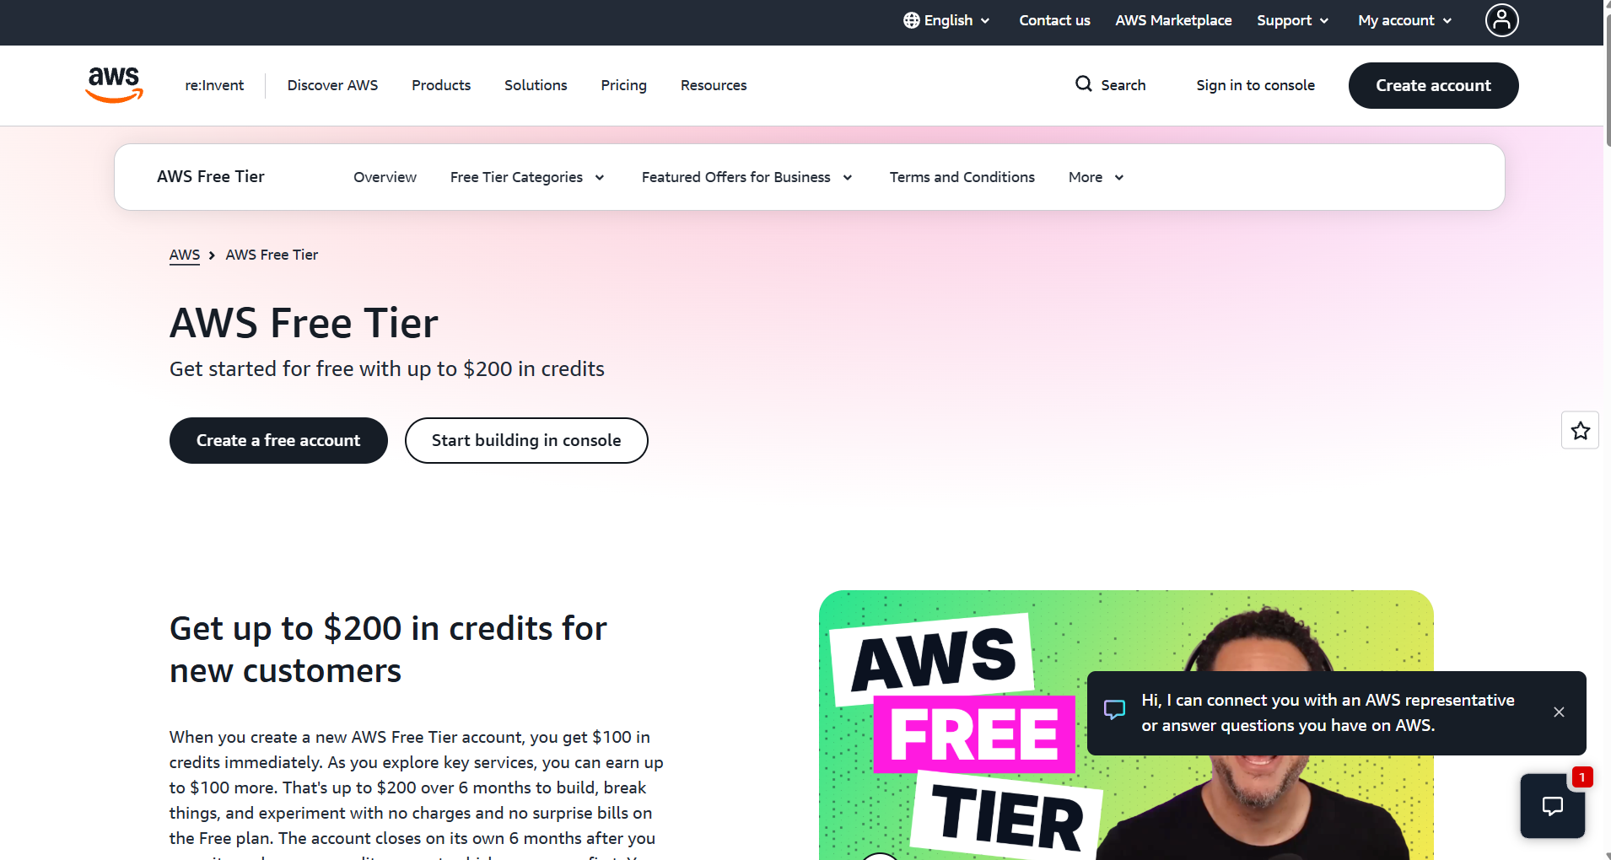
IAM user creation and permission selection
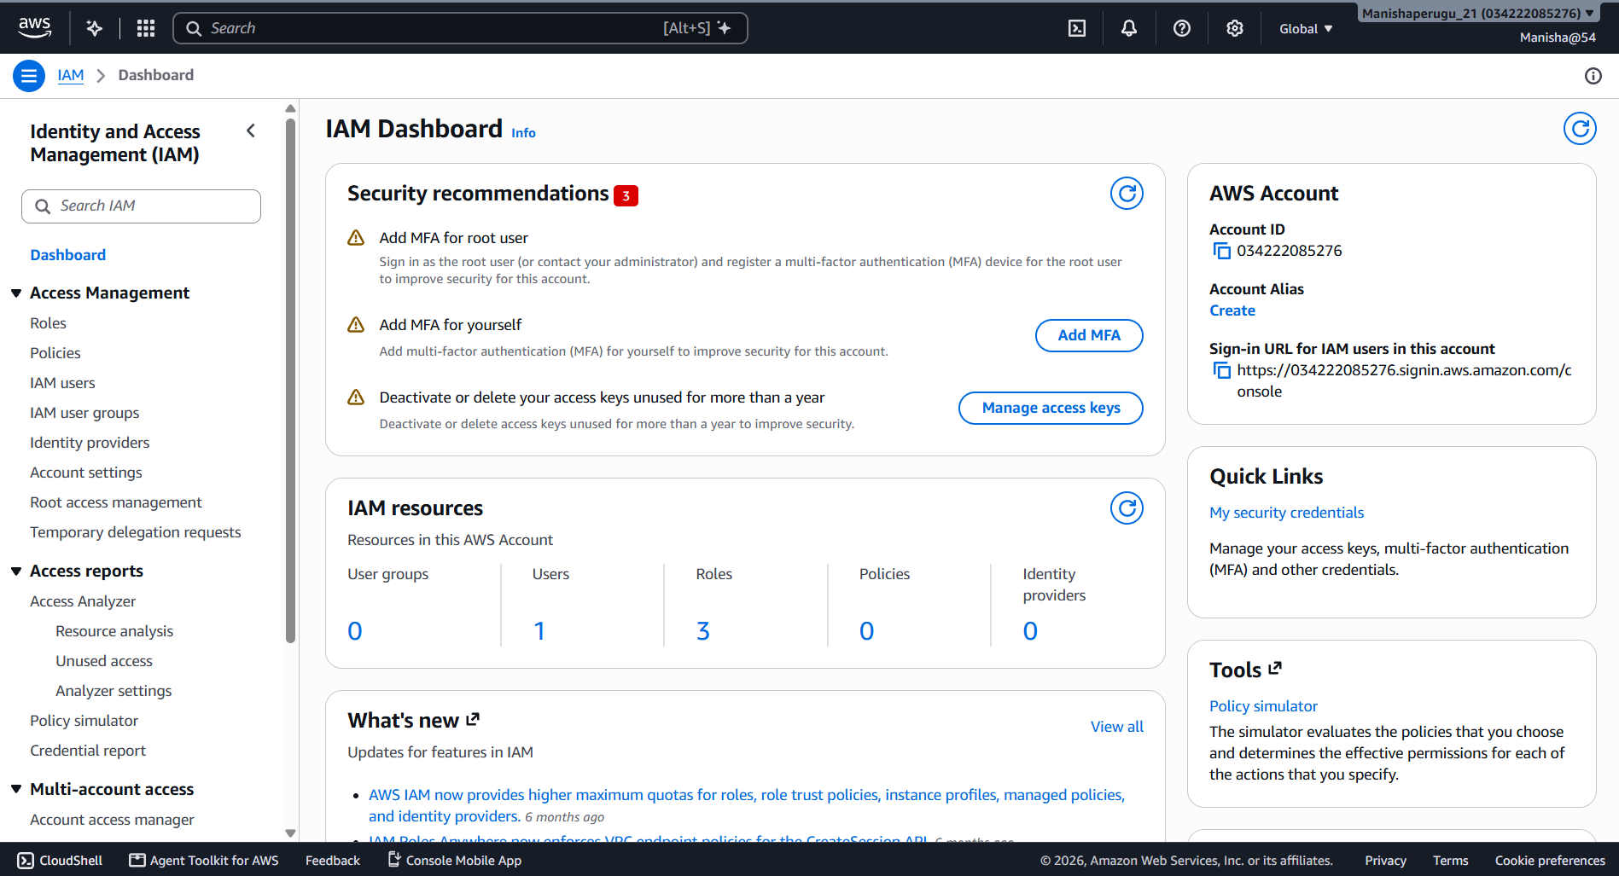

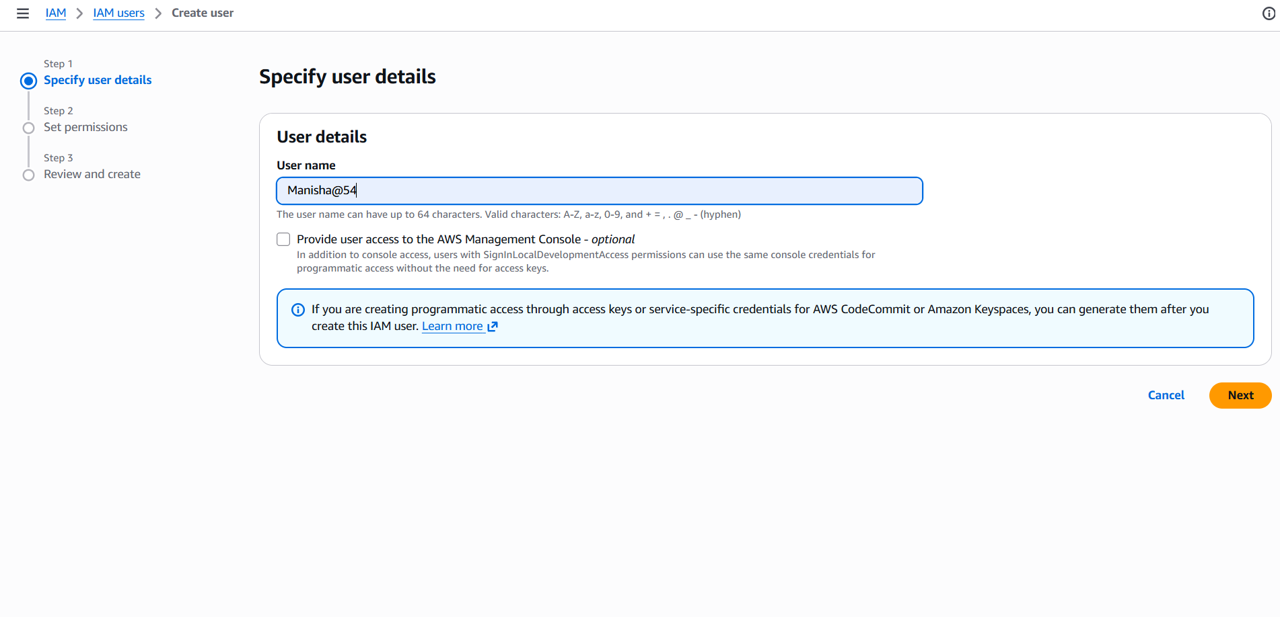

User details and IAM user setup
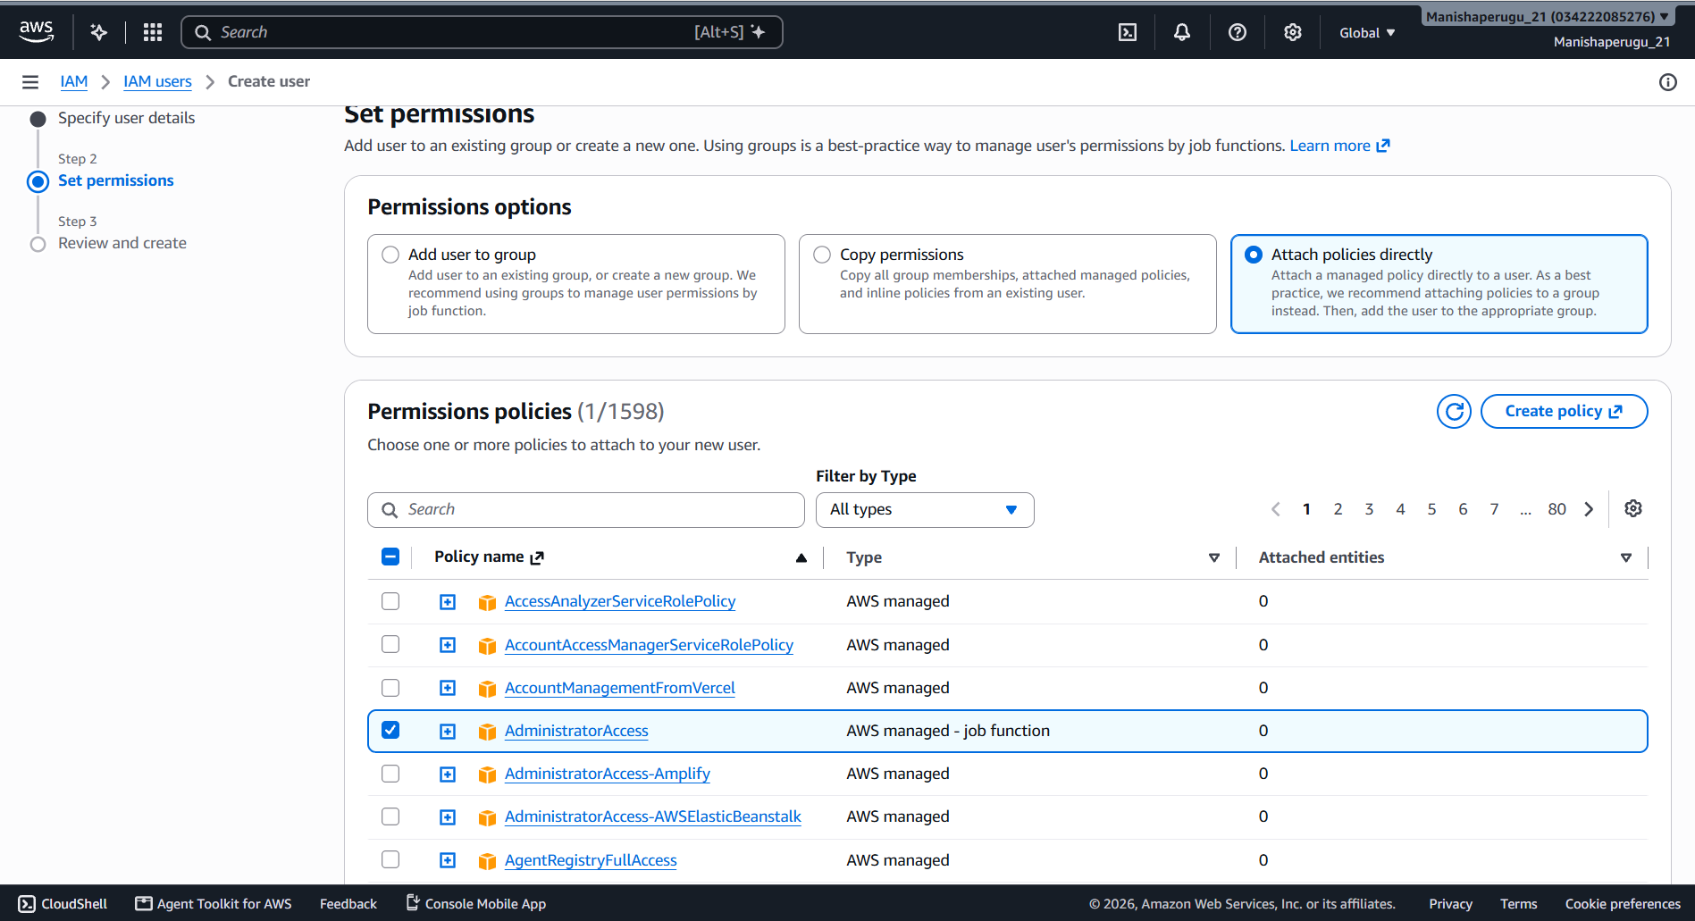
Created IAM user and user summary

Security credentials and console access settings
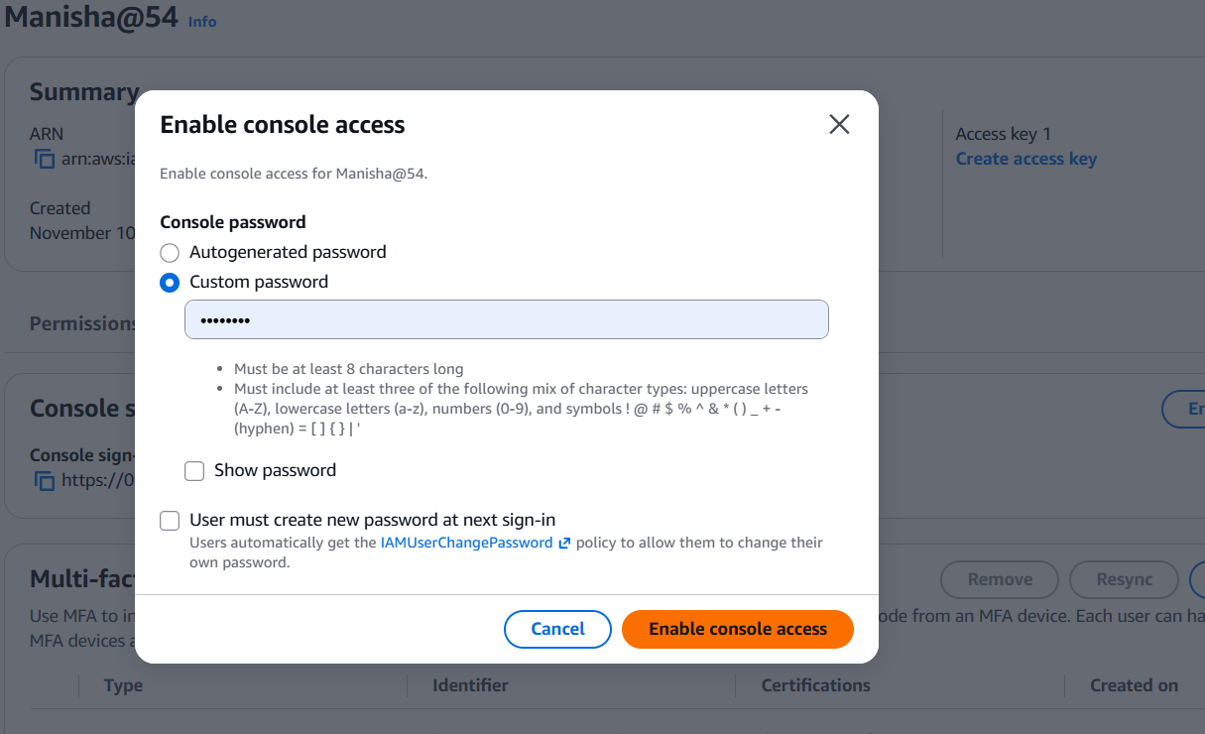
AWS console home page
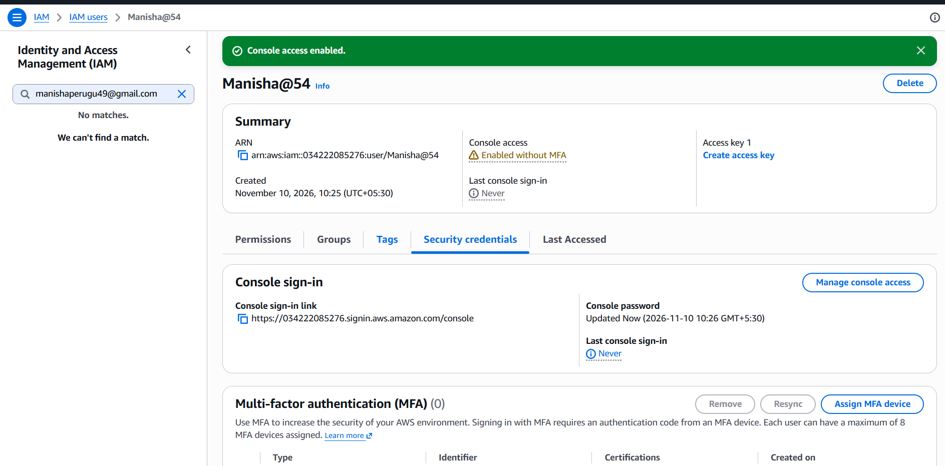
Access key creation and security credentials
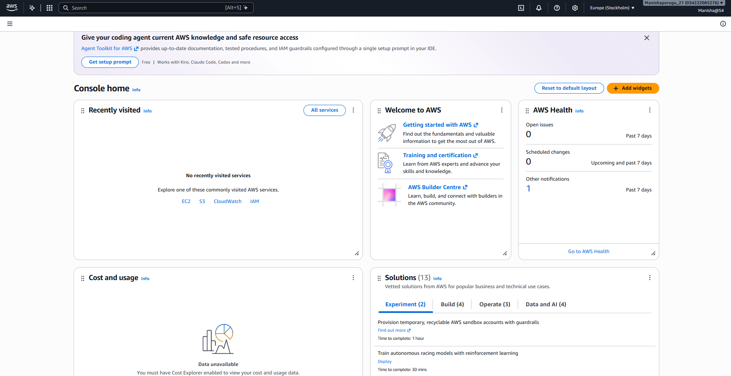
Billing and Cost Management budget setup and email alert
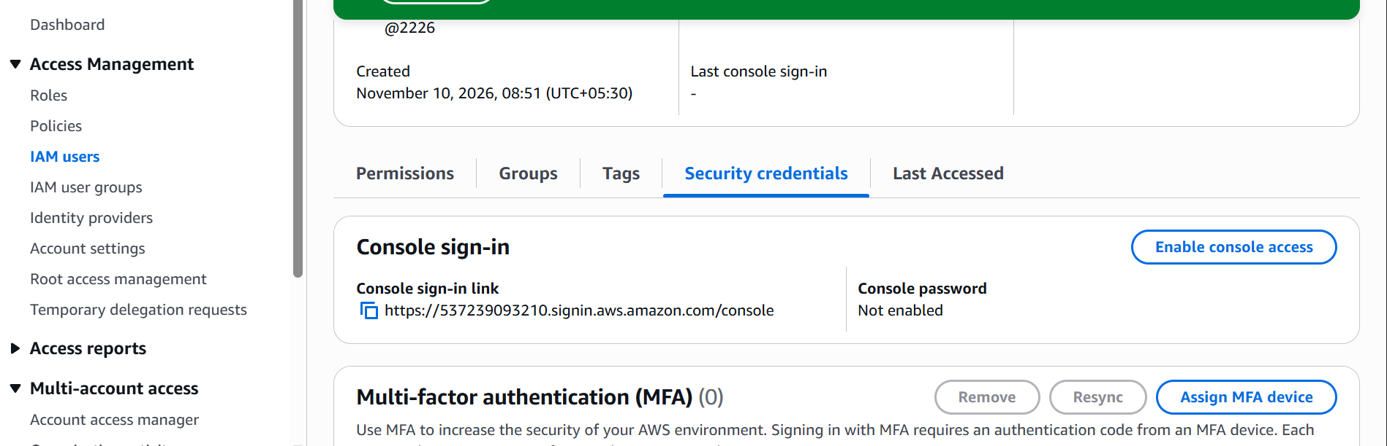

AWS setup screenshot 9
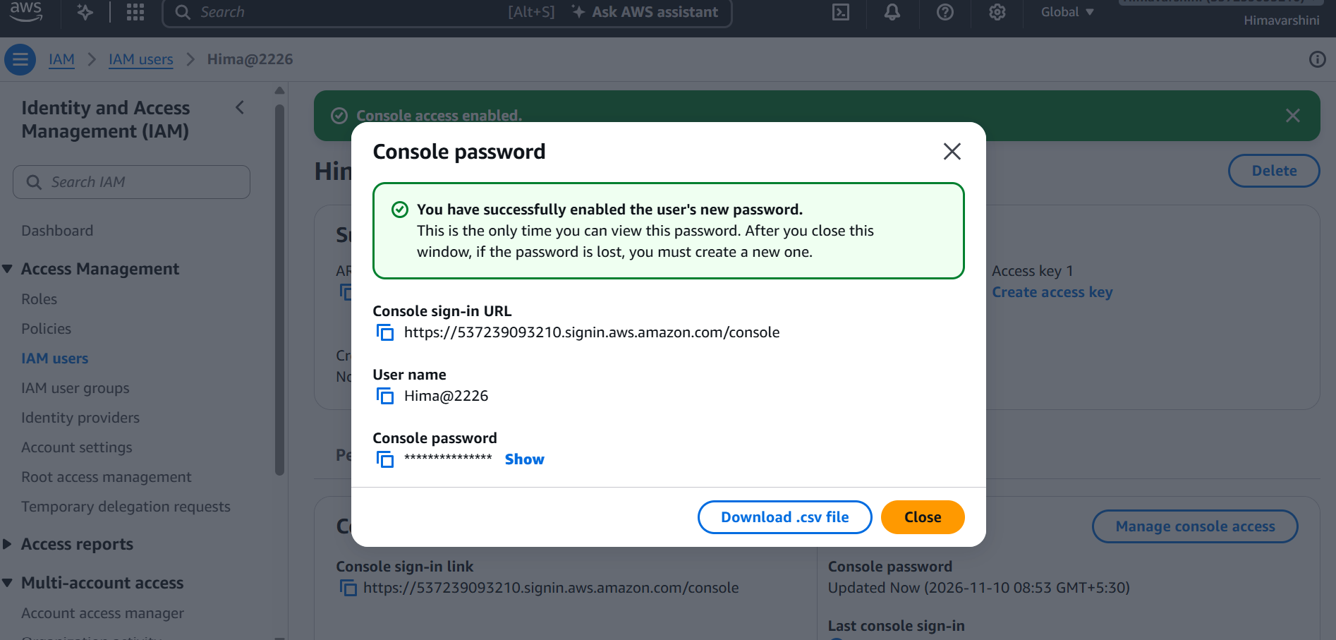
AWS setup screenshot 10
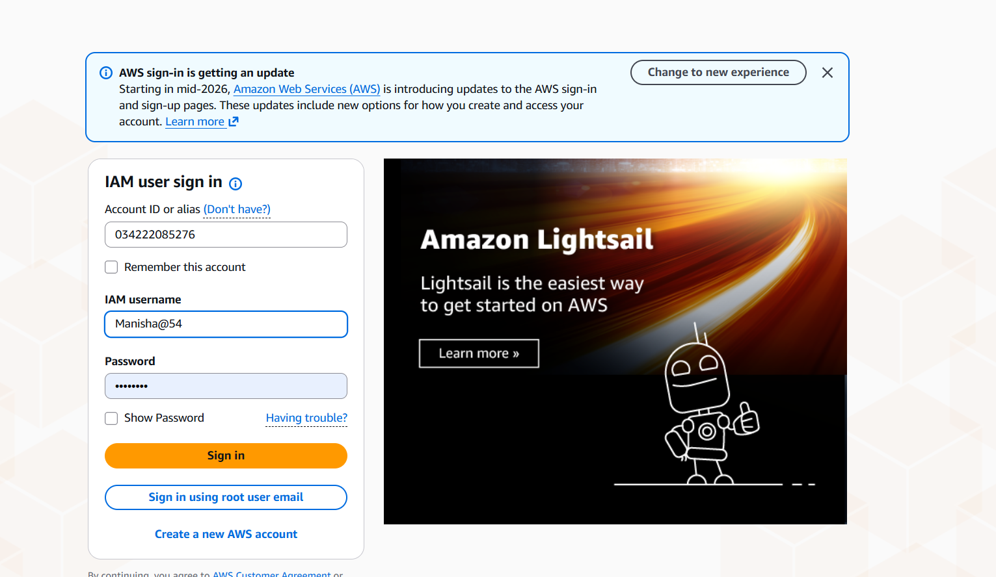
AWS setup screenshot 11
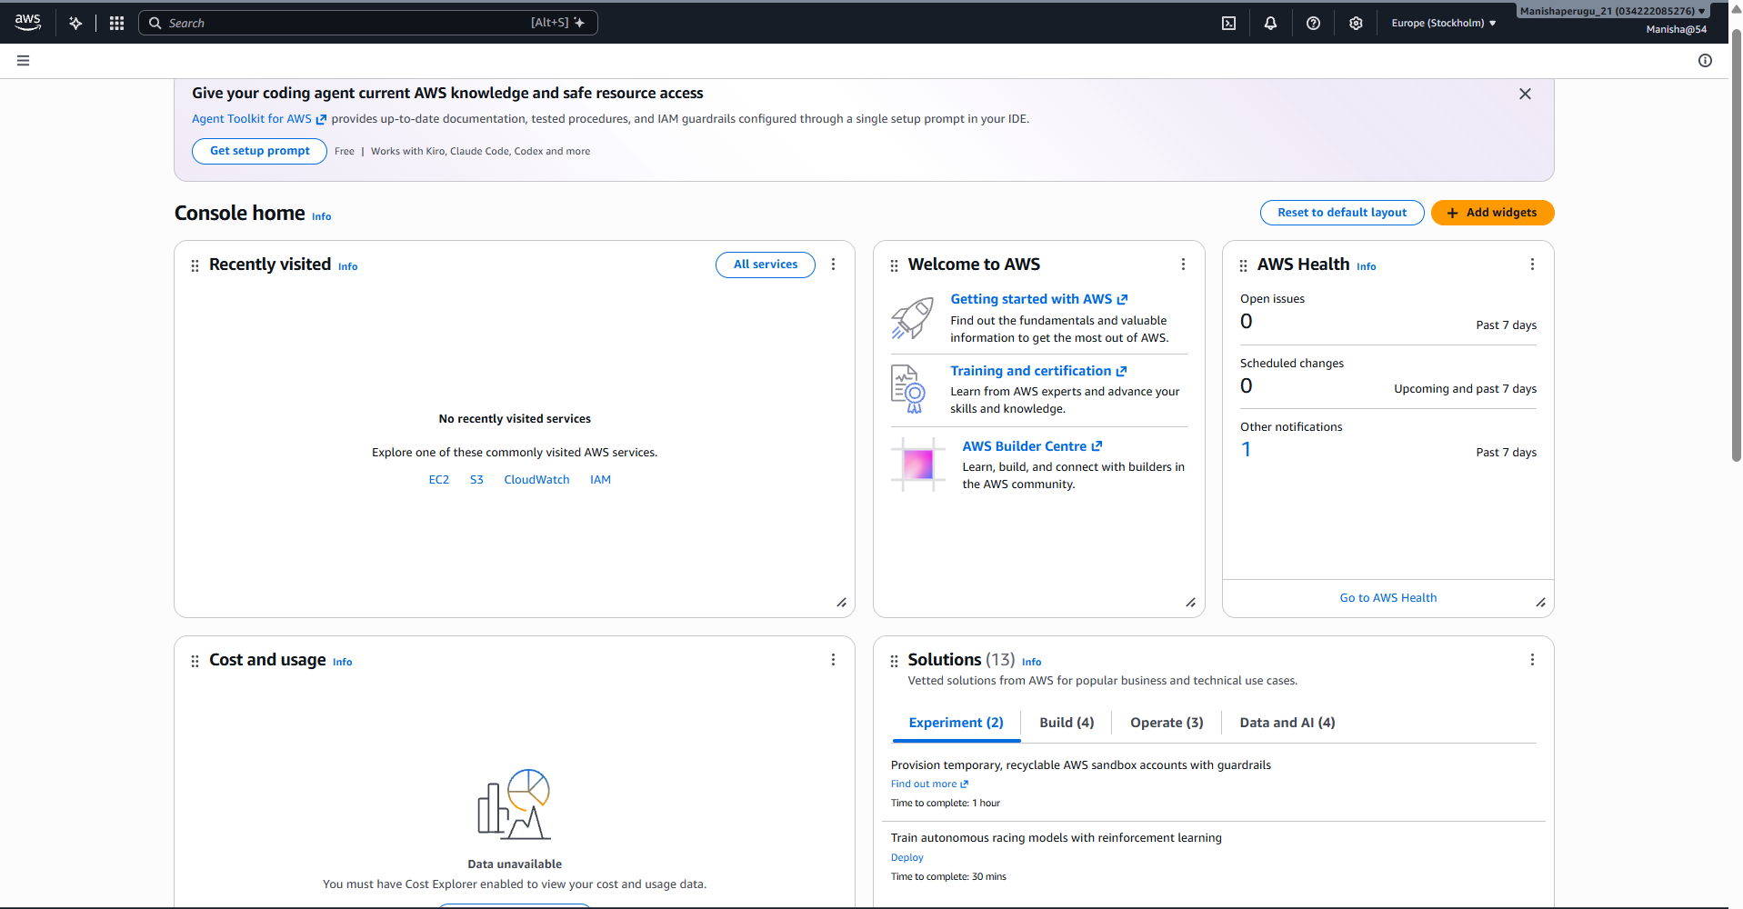

AWS setup screenshot 12
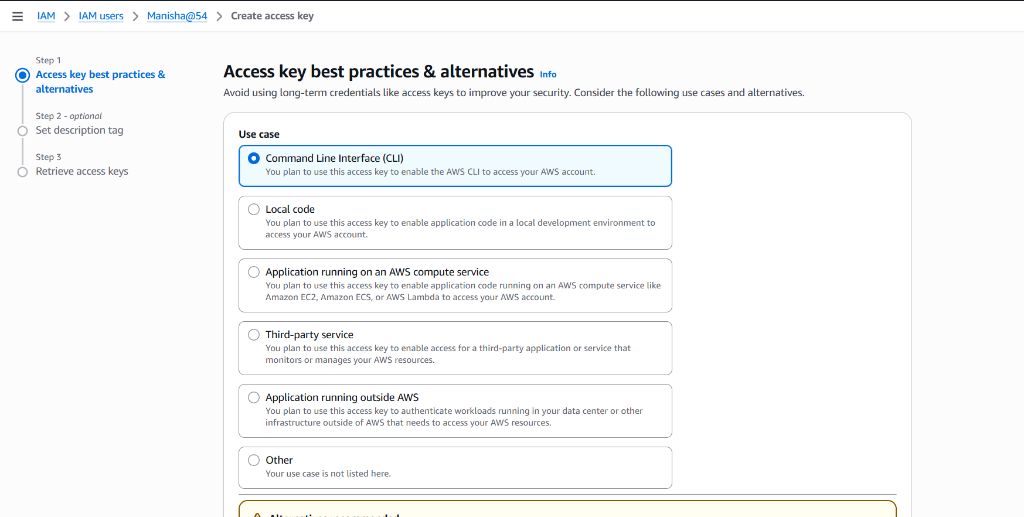

AWS setup screenshot 13
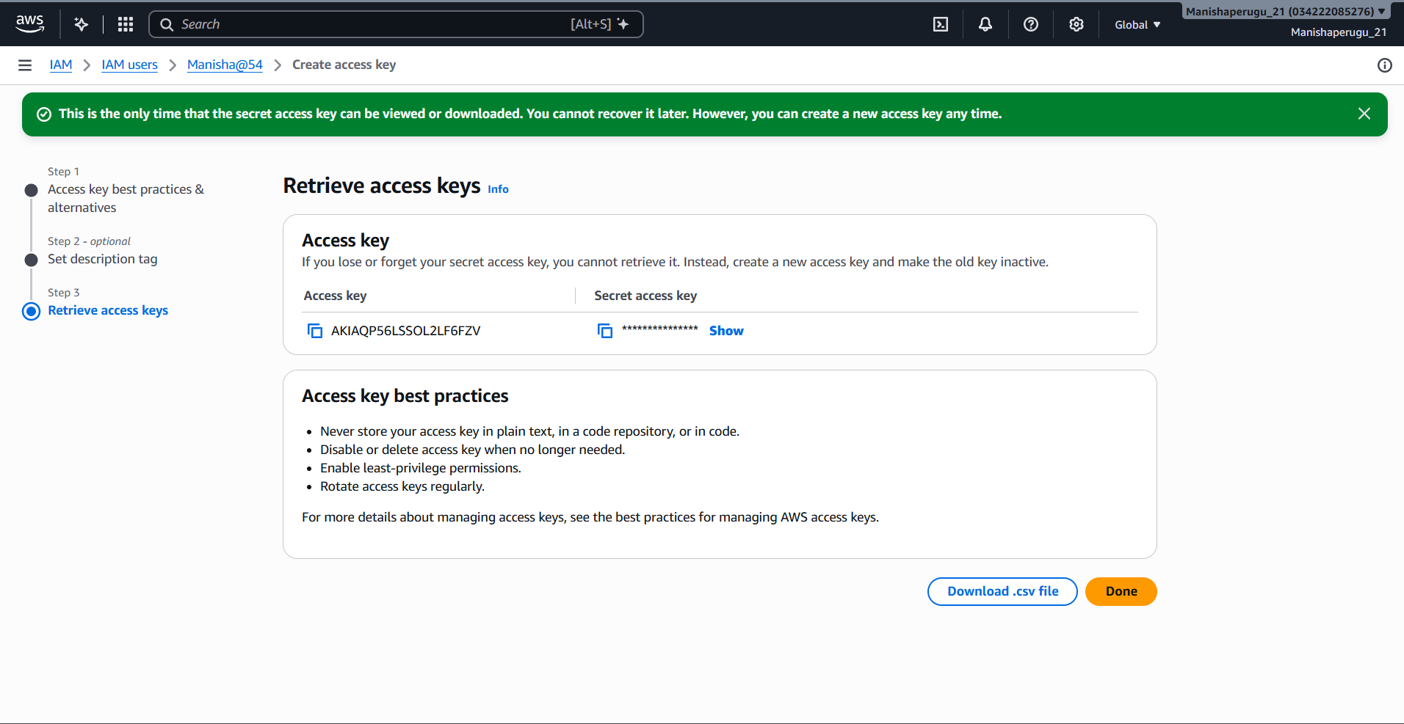

AWS setup screenshot 14
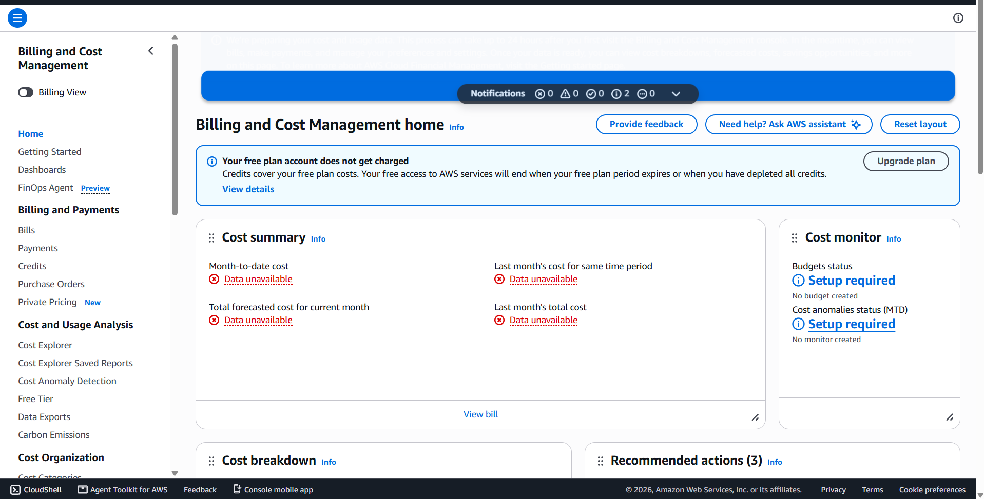
AWS setup screenshot 15
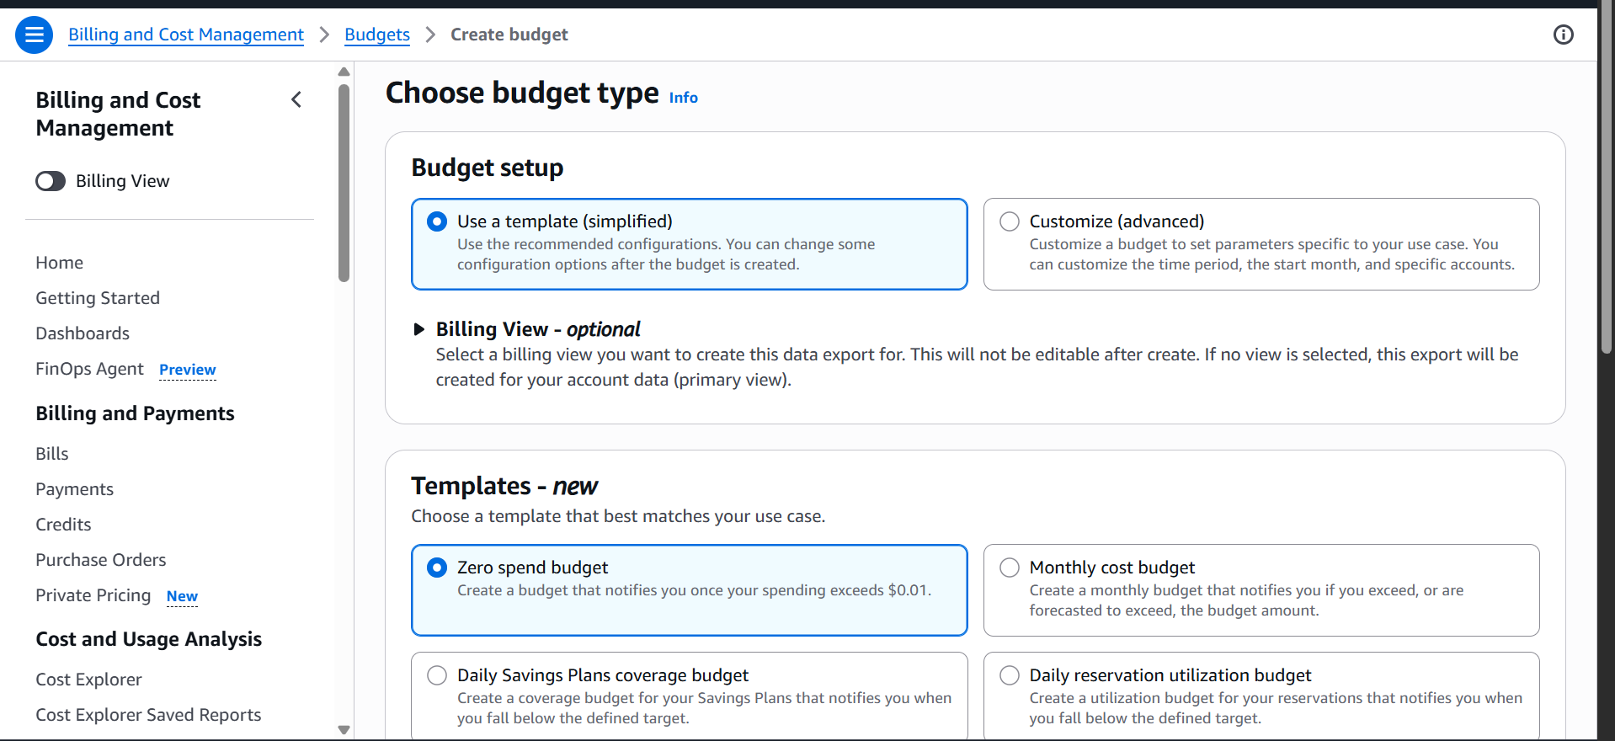

AWS setup screenshot 16
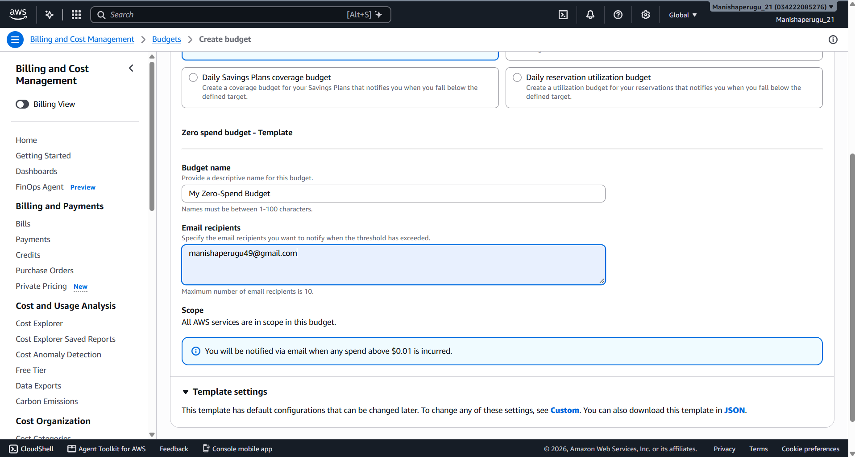
AWS setup screenshot 217
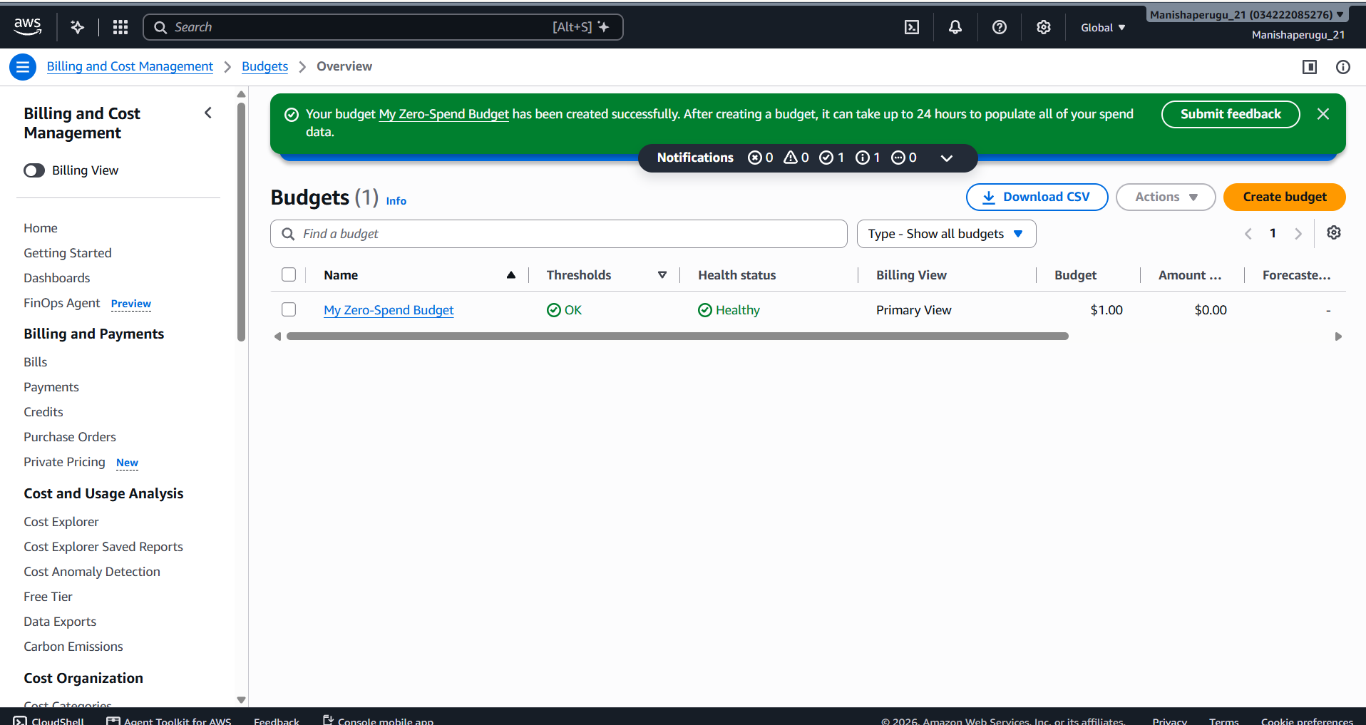

Output:
The IAM user was created successfully with programmatic access, and the access credentials were downloaded. The AWS budget was created with an email notification recipient to monitor usage and alert when the configured threshold is reached.

